
Persons completing this assessment should refer to the UCD Chemical Safety Manual, the associated chemical safety guides as necessary, and must review the SDS for the chemicals under assessment.

1. General Information

Name of Person(s) involved in the Process and their Position | Celb30010 students
Principal Investigator / Supervisor  (Person responsible for ensuring safety) | Module coordinator
Date of Assessment | 29/01/25
Location of Works | – Science East 1st floor
Frequency of Process | 2-3 times a year

2. Title and Details of the Process Involving the use of Hazardous Agents – give details of the process(es) in question - if necessary, attach a written procedure. Please describe the entire lifecycle of chemical usage from delivery to disposal. Include details of any hazardous reaction products or wastes generated and how these are to be managed.

Title of Process: RNA extraction from cultured cells
Details:
- Remove ALL the tissue culture medium from the plate of cells.
- Add 1.2 ml of RNA STAT-60 TM reagent (tube labelled RS) onto the cells. Swirl around in the plate making sure that the surface of the entire plate is covered.
- Pass the lysate through a P1000 pipette tip several times
- Transfer 600 μl of the lysate to a 1.5 ml microfuge tube and incubate at room temperature for 5 min.
- Add 60 μl of BCP (bromochloropropane) to the tube with the cell lysate and close the lid TIGHTLY
- Shake vigorously for 15 sec.
- Incubate for 10 min at room temperature.
- Place the tubes in the centrifuge and spin for 10 min at 14,000 rpm at 4ºC.
- Carefully transfer 250 μl of the upper aqueous phase into a new 1.5ml tube using a P200 pipette (2x125 μl), making sure not to disturb the aqueous/ organic interface
- Add an equal volume of Isopropanol (250 μl).
- Vortex briefly and incubate for 10 min at room temperature
- Place the tube in the microcentrifuge and spin at 14,000 rpm for 10 min at 4ºC. The RNA will form a small pellet at the bottom of the tube.
- Carefully remove and discard the supernatant using a P200 pipette without dislodging the pellet
- Add 500 μl of 75% Ethanol to wash the RNA pellet.
- Vortex to dislodge the pellet from the bottom of the tube and centrifuge for 5 min at 14,000 rpm at 4ºC.
- Remove all the ethanol using a P200 pipette and allow the pellet to dry at room temperature for 5 min.
- Add 50 μl of RNAse free water to re-suspend the pellet and incubate the tube in the heating block at 55ºC for 10 min.

CHEMICAL AND BIOLIGICAL HAZARD SECTIONS ARE BELOW THIS TABLE

Hazard |  |  |  | Risk(s) | Control Measure(s)
- Physical hazards  (e.g. manual handling, slips/trips, poor housekeeping, working in hot/cold environments, fire) |  | N/A
Residual Risk Rating:
- Health hazards  (e.g. noise, dust, fumes, vibrations, working in poor or excessive light) | Exposure to chemical vapours  (TRIzol, chloroform) |  |  | Respiratory irritation, headaches, dizziness | Work in fume hood; keep containers closed when not in use; avoid breathing vapours
Residual Risk Rating: Acceptable
- Equipment hazards  (e.g. centrifuges, autoclaves, ULT freezers, gel rigs, power packs, water baths, pH meters, plant growth rooms/chambers etc) |  |  | Centrifuge | Mechanical injury if improperly balanced or lid opened while spinning | Training on proper use; visual inspection before operation; never open lid while rotor is in motion; proper balancing of tubes
Residual Risk Rating:Trivial
- Waste hazards  (e.g. waste streams) |  |  | Chemical waste (TRIzol, chloroform, isopropanol) | Environmental contamination, exposure during handling | Collect waste in properly labeled containers; follow institutional waste disposal protocols; handle with appropriate PPE
 |  |  | Biological waste (mammalian cells) | Biohazard contamination | Decontaminate with appropriate disinfectant; dispose in biohazard waste containers
Residual Risk Rating: Acceptable

3. Hazardous Agent(s) to be used

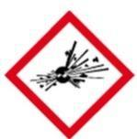  GHS01 | 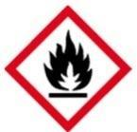  GHS02 | 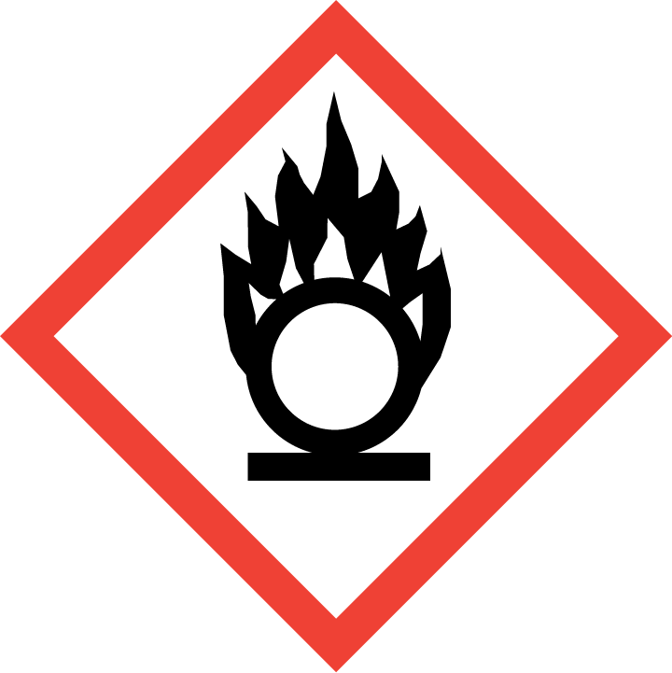  GHS03 |  | GHS04  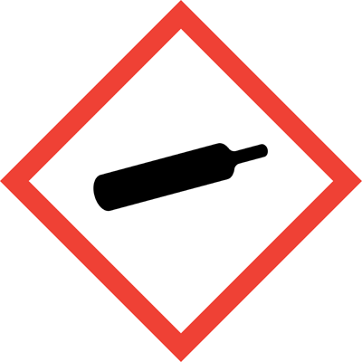 |  | 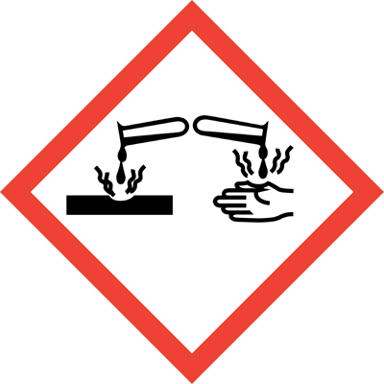  GHS05 | 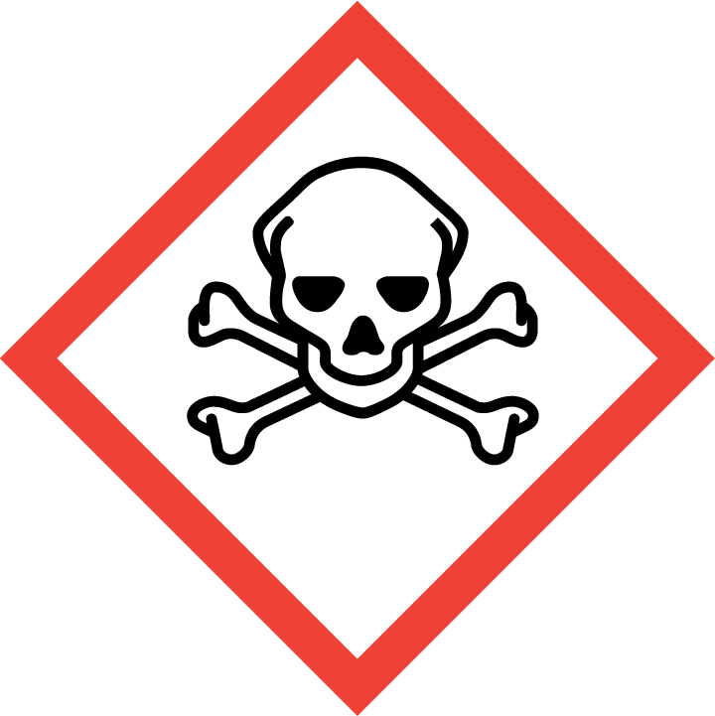  GHS06 | 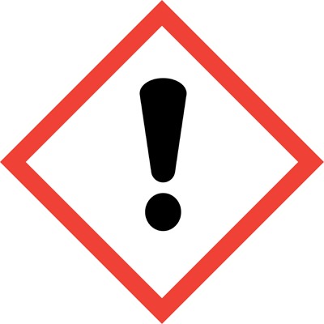  GHS07 |  | 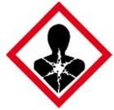  GHS08 | GHS09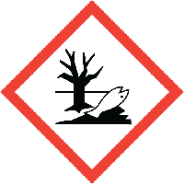
☐ | ☐ | ☐ |  |  | ☐ | x | ☐ | X |  | X | ☐
Chemical name (or formula where no name) |  |  | TRIZOL |  |  | Hazard Statements |  |  | H302 - Harmful if swallowed H312 - Harmful in contact with skin  H332 - Harmful if inhaled H314 - Causes severe skin burns and eye damage  H341 - Suspected of causing genetic defects
Hazard Class |  |  | Acute oral toxicity Acute dermal toxicity Acute inhalation toxicity Category 4  Skin corrosion/irritation Serious eye damage/eye irritation Category 1  Germ cell mutagenicity Category 2 Specific target organ toxicity - Repeated exposure Category 2
Signal Word |  |  | Danger |  |  | Precautionary Statements |  |  | P264 - Wash hands thoroughly after handling  P280 - Wear protective gloves/protective clothing/eye protection/face protection P261 - Avoid breathing dust/fume/gas/mist/vapours/spray  P270 - Do not eat, drink or smoke when using this product P271 - Use only outdoors or in a well-ventilated area  P201 - Obtain special instructions before use  P260 - Do not breathe dust/fume/gas/mist/vapours/spray  P273 - Avoid release to the environment  P202 - Do not handle until all safety precautions have been read and understood  Required – only the code is not enough!
Amount |  |  | 1.5ml
Form |  |  | Liquid
(Add additional tables as required) - Use one table for each hazardous agent.

GHS01 | GHS02 | GHS03 |  | GHS04 |  | GHS05 | GHS06 | GHS07 |  | GHS08 | GHS09
☐ | X | ☐ |  |  | ☐ | ☐ | ☐ | X |  | ☐ | ☐
Chemical name (or formula where no name) |  |  | Isopropanol  2-Propanol |  |  | Hazard Statements |  |  | H225 - Highly flammable liquid and vapor  H319 - Causes serious eye irritation  H336 - May cause drowsiness or dizziness
Hazard Class |  |  | Flammable liquids Category 2 (H225)  Serious Eye Damage/Eye Irritation Category 2 (H319)Specific target organ toxicity - (single exposure) Category 3 (H336
Signal Word |  |  | Danger |  |  | Precautionary Statements |  |  | P210 - Keep away from heat, hot surfaces, sparks, open flames and other ignition sources. No smoking  P240 - Ground and bond container and receiving equipment  P261 - Avoid breathing dust/fume/gas/mist/vapors/spray  P280 - Wear protective gloves/protective clothing/eye protection/face protection  P305 + P351 + P338 - IF IN EYES: Rinse cautiously with water for several minutes. Remove contact lenses, if present and easy to do. Continue rinsing
Amount |  |  | 1.5 ml
Form |  |  | Liquid
(Add additional tables as required) - Use one table for each hazardous agent.

GHS01 | GHS02 | GHS03 |  | GHS04 |  | GHS05 | GHS06 | GHS07 |  | GHS08 | GHS09
☐ | X | ☐ |  |  | ☐ | ☐ | ☐ | X |  | ☐ | ☐
Chemical name (or formula where no name) |  |  | Ethanol |  |  | Hazard Statements |  |  | H225 - Highly flammable liquid and vapor  H319 - Causes serious eye irritation
Hazard Class |  |  | Flammable liquids, (Category 2) H225: Highly flammable liquid and vapor.  Eye irritation, (Category 2) H319: Causes serious eye irritation.
Signal Word |  |  | Danger |  |  | Precautionary Statements |  |  | P210 - Keep away from heat, hot surfaces, sparks, open flames and other ignition sources. No smoking  P240 - Ground and bond container and receiving equipment  P233 Keep container tightly closed.  P241 -Use explosion-proof electrical/ ventilating/ lighting/ equipment.  P242- Use non-sparking tools.  P305 + P351 + P338 - IF IN EYES: Rinse cautiously with water for several minutes. Remove contact lenses, if present and easy to do. Continue rinsing
Amount |  |  | 2-3ml
Form |  |  | Liquid

GHS01 | GHS02 | GHS03 |  | GHS04 |  | GHS05 | GHS06 | GHS07 |  | GHS08 | GHS09
☐ | x | ☐ |  |  | ☐ | ☐ | x | ☐ |  | x | ☐
Chemical name (or formula where no name) |  |  | BCP reagent  3-chloropropyl bromide |  |  | Hazard Statements |  |  | H226 Flammable liquid and vapor  H302 Harmful if swallowed  H332 Harmful if inhaled  H341 Suspected of causing genetic defects
Hazard Class |  |  | Flammable liquids Category 3  Acute toxicity, oral Category 4  Acute toxicity, inhalation Category 3  Germ cell mutagenicity Category 2
Signal Word |  |  | Danger |  |  | Precautionary Statements |  |  | P210 Keep away from heat/sparks/open flames/hot surfaces. No smoking.  P233 Keep container tightly closed.  P235 Keep cool.  P261 Avoid breathing dust/fumes/gas/mist/vapors/spray.  P264 Wash…thoroughly after handling.  P270 Do not eat, drink or smoke when using this product.  P271 Use in a well-ventilated area.  P273 Avoid release to the environment  P280 Wear protective gloves/protective clothing/eye protection/face protection.
Amount |  |  | 1.5 ml
Form |  |  | Liquid

Has a safer alternative(s) been considered for all chemicals (give details)?

BCP is used instead of Chloroform to reduce the Health risk associated with it.
____________________________________________________________________________________________________________________________________________________________________

Provide scientific justification for the use of chemicals classed as Carcinogen, Mutagen or Reproductive Toxin
__ TRIzol and BCP are classified as potential carcinogens, mutagens, or reproductive toxins. Their use is justified as they are essential components for efficient RNA extraction with high yield and quality. TRIzol is designed to maintain RNA integrity during cell lysis and separation of RNA from DNA and proteins. BCP is necessary for phase separation of the aqueous RNA-containing phase from the organic phase containing DNA and proteins. Currently, there are no equally effective alternatives with significantly lower hazard profiles for this specific laboratory application that would provide the same quality of RNA required for downstream applications.
__________________________________________________________________________________________________________________________________________________________________

Are any of the chemicals in use incompatible and likely to give rise to a potentially dangerous reaction or generate hazardous reaction products (give details): ____________________________________N/A______________________________________________
Check potential reactions with the Chemical Reactivity Worksheet

Location of SDS for each Chemical: Lab E1.56 Folder and electronic copies on shared drive
(Safety Data Sheets)

4. Potential Experimental / Reaction Outcomes (give details where applicable)

Exothermic: ☐ Explosive: ☐ Release of gas / vapours: ☐ Pressurisation: ☐
Generation of unstable compounds: ☐ Effects on normal atmospheric conditions: ☐
Other: ☐ __________________________________________________________________________________

5. Reaction Products & Waste
If possible list the reaction products generated and indicate their hazards -

Reaction Products | N/A

GHS01 | GHS02 | GHS03 | GHS04 |  | GHS05 | GHS06 | GHS07 | GHS08 | GHS09
☐ | ☐ | ☐ |  | ☐ | ☐ | ☐ | ☐ | ☐ | ☐
(Add additional tables as required)

If possible list the wastes generated and indicate their hazards -
Wastes Generated
- TRIzol waste (containing phenol and guanidinium thiocyanate)
- Chloroform waste
- Alcohol waste (isopropanol and ethanol)
- Mixed aqueous/organic waste from phase separation

GHS01 | GHS02 | GHS03 | GHS04 |  | GHS05 | GHS06 | GHS07 | GHS08 | GHS09
☐ | x | ☐ |  | ☐ | x | x | x | x | x
(Add additional tables as required)

6. Potential Exposure*

- Who (and how many) could potentially be exposed to these chemicals. Consider all stages of the chemicals’ lifecycle from delivery through to disposal. | Laboratory personnel performing the extraction - Laboratory staff handling waste disposal  Potentially other lab users working in the same area.
- Is there a part of the process which could lead to a release of the chemical into the air or onto a surface (give details)?  What controls are in place to prevent this? | Opening TRIzol and chloroform bottles may release vapours  Pipetting and vortexing may cause aerosol formation.  Potential for spills during all liquid handling steps  Controls:  All work with TRIzol and chloroform performed in fume hood- Secure capping of tubes before vortexing  - Use of secondary containment trays  Proper pipetting techniques to avoid aerosol formation  - Immediate cleanup of any spills
- What are the potential routes of exposure? (Inhalation, ingestion, dermal, transplacental, sharps) | Inhalation: Vapours from TRIzol and chloroform  Dermal: Direct contact with chemicals during handling  Ingestion: Accidental ingestion through hand-to-mouth contact  Eye: Splashes during pipetting or handling
- What steps have you taken to minimise or eliminate the potential routes of exposure identified? | Inhalation: Use of fume hood for all steps involving open containers of TRIzol and chloroform  Dermal: nitrile gloves, lab coat, closed-toe shoes  >Ingestion: No eating/drinking in lab, handwashing after procedure Eye: Safety glasses or goggles
- What is the chance of the exposure occurring? (Unlikely, Likely, Very Likely) | Unlikely if all recommended control measures are implemented
- Concentration / intensity, duration and frequency of exposure | Concentration: Pure TRIzol reagent and BCP Duration: 2-3 hours per procedure  Frequency: every 2-3 months
* for carcinogens, mutagens and reproductive toxins the objective should be to eliminate exposure

7. Controls in Place
- PPE in use | Lab Coat: x Safety Glasses: x  Safety Goggles: ☐ Face Shield: ☐ Gloves: x (indicate type)_____Nitrile_______  Other: ☐ (give details) _____________
- Engineering controls | Fume hood: x Other: : ☐  * LEV / Desk Exhaust: : ☐  * only suitable for low risk activities involving low risk materials.
- Other controls
- Storage arrangements (ensure incompatibles are separated) | TRIzol stored in original container in [location, e.g., "chemical storage cabinet"]  BCP stored in amber bottles in vented cabinet F  Flammable solvents (isopropanol, ethanol) stored in flammable storage cabinet
- Waste disposal procedure | All TRIzol and chloroform waste collected in dedicated hazardous waste containers  Flammable waste (isopropanol, ethanol) collected separately  All waste containers kept closed and labelled

8. Further Risk Control Measures These additional risk control measures should be designed to tackle the hazards identified in Sections 3, 4, 5, and 6 above. All questions must be answered.
- Can any of the hazardous agents be replaced with less hazardous materials? (give details) | We have replaced Chloroform with BCP
- Can the amount of chemical in use be reduced? | No
- Can the duration / intensity of exposure / numbers of persons exposed be reduced? | no
- Are further safety / hygiene facilities required? | no
- Is warning signage required? | no
- Are transport or storage arrangements contributing to risk? | no
- Is appropriate first aid equipment / antidotes available? | Not necessary
- Is additional safety equipment required? | no
- In the case of carcinogens, mutagens and reproductive toxins are storage and labelling provisions adequate? | yes
- In the case of carcinogens, mutagens and reproductive toxins can a sealed working system be used? | Not necessary
- In the case of carcinogens, mutagens and reproductive toxins does the working area require demarcation? | no
- In the case of carcinogens, mutagens and reproductive toxins do the users require medical surveillance? | no
- Can the process be modified to reduce exposure risks? | no
- Is further training for personnel required? | Yes. All personnel must be trained on hazards of chemicals, proper use of fume hood, and emergency procedures before conducting procedure.
- Can different equipment be used to control risk? | no
- Is further PPE required? | no
- Can engineering controls be put into place? | no
- Is the product of the process creating a high risk that can be reduced? | no
- Does the working area require demarcation? | no
- Are safe handling procedures in place? | yes
- Is occupational exposure monitoring required? | N/A
- Do ignition sources require isolation? | NA
- Can the emergency responses be improved? | NA
- Is health surveillance required? | no

9. Emergency Responses (Consult relevant SDS for further information)

 | Response Measures | Location of kits / specialist or response equipment
- Fire | For small fires, use appropriate fire extinguisher (CO2 or dry chemical)  For larger fires, evacuate area and call emergency services  Do not use water on chemical fires | Fire Extinguishers and Fire  Blankets are located in each lab
- First Aid | Eye contact: Flush with water for at least 15 minutes at eyewash station  Skin contact: Remove contaminated clothing, wash with soap and water for 15 minutes  Inhalation: Move to fresh air  Ingestion: Do not induce vomiting  For all exposures, seek medical attention immediately | Hand Washing Sink.  First aid box located.  Contact UCD Medical or  ambulance service (Ext. 7999)  Emergency Shower and eye wash stations located in each teaching lab

10. Risk Rating

 | Severity
Likelihood |  | Low ☐ | Medium ☐ | High ☐
 | Low ☐ | Trivial | Acceptable | Moderate
 | Medium ☐ | Acceptable | Moderate | Substantial
 | High ☐ | Moderate | Substantial | Intolerable

Assessment of likelihood and Severity

 | Severity of Outcome | Likelihood of Exposure
Low | Slightly Harmful | Unlikely
Medium | Harmful | Likely
High | Very Harmful | Very Likely

Severity | Likelihood | Risk Rating
Harmful | Unlikely | Acceptable

- Trivial Risk: No further action needed
- Acceptable Risk: No additional risk control measures required
- Moderate Risk: Implement further risk control measures if possible
- Substantial Risk: Further control measures must be implemented. If this is not possible then work must be strictly managed to ensure safety.
- Intolerable: Work must be prohibited until further control measures are implemented.

Is the risk rating acceptable: Yes: x No: ☐
If yes, sign and date below and ensure all risk control measures have been implemented.
If no, identify further control measures and reassess risk. If the risk cannot be reduced to an acceptable level then the process cannot be carried out.

Is this work suitable for lone working: Yes: ☐ No: x

Signed: Date: Position:

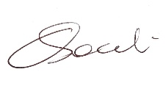
________________ ______29/01/25____ ______CTO II__________

Signed: Date: Position:

________________ ___________ ________________

This document must be signed by the person carrying out the assessment and their academic supervisor / manager (person responsible for ensuring safety).

